H.T No
Regulations:
A19

Sreenidhi Institute of Science and Technology
(An Autonomous Institution)
Code No: 7P261 Date: 18-Aug-2023 (FN)

M.Tech I-Year II- Semester External Examination, Aug/Sept-2023 (Supplementary)
ARTIFICIAL INTELLIGENCE & DEEP LEARNING (CSE and CS)

Time: 3 Hours Max.Marks:70

Note: a) No additional answer sheets will be provided.
b) All sub-parts of a question must be answered at one place only, otherwise it will not be valued.
c) Missing data can be assumed suitably.
Bloom's Cognitive Levels of Learning (BCLL)

Remember | L1 | Apply | L3 | Evaluate | L5
Understand | L2 | Analyze | L4 | Create | L6

Part - A Max.Marks:20

Answer all QUESTIONS.

 |  | BCLL | CO(s) | Marks
1 | Define Rational Agent. | L1 | CO1 | [2M]
2 | Define the following terms: i) State, ii) Initial State | L1 | CO2 | [2M]
3 | Translate the following sentences into formulas in predicate logic  (i) Every student loves some other student.  (ii) There is a student who is loved by every other student. | L5 | CO3 | [2M]
4 | What is the need for probability theory in uncertainty? | L1 | CO4 | [2M]
5 | What are convolution filters? | L2 | CO5 | [2M]
6 | What are Deep Q-networks? | L1 | CO6 | [2M]
7 | List the properties of planning. | L1 | CO2 | [2M]
8 | Define Predicate logic with example. | L1 | CO4 | [2M]
9 | Write the formula to predict number of neurons in CNN required for next layer if window size (W), filter size (F), padding (P) and stride (S) is provided. | L3 | CO5 | [2M]
10 | Define Bayes rule. | L1 | CO6 | [2M]

Part – B Max.Marks:50
ANSWER ANY FIVE QUESTIONS. EACH QUESTION CARRIES 10 MARKS.

 |  |  | BCLL | CO(s) | Marks
11. | a) | What is Artificial Intelligence? What are the various applications of Artificial Intelligence? | L1 | CO1 | [5M]
 | b) | Discuss problem solving agents. | L1 | CO1 | [5M]
12. | a) | In the graph below the start state is S, and the goal state is G. The transition costs are next to the edges, and the heuristic estimate, h, of the distance from the state to the goal is in the state's node. Assume ties are always broken by choosing the state which comes first alphabetically.  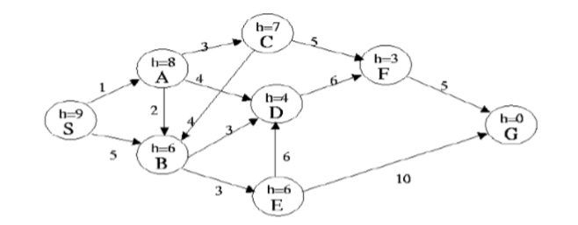  What is the order of states expanded using A* Search | L5 | CO2 | [5M]
 | b) | Write minmax algorithm which is used in game search. | L1 | CO2 | [5M]
13. | a) | Prove that “Jill killed the cat” using resolution refutation.  i) Everyone who loves all animals is loved by someone.  ii) Anyone who kills an animal is loved by no one.  iii) Tack loves all animals  iv) Either Jack or Jill killed the cat whose name is Tina | L5 | CO3 | [5M]
 | b) | Discuss issues in Knowledge representation | L1 | CO3 | [5M]
14. | a) | In the following acyclic MDP calculate V(P) where C(a)=4, C(b)=9 C(c)=1  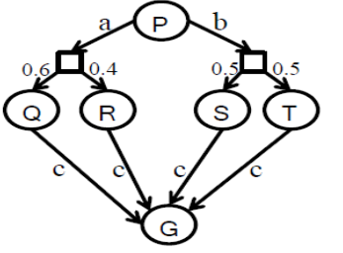 | L5 | CO4 | [5M]
 | b) | Differentiate between value iteration and policy iteration | L4 | CO4 | [5M]
15. | a) | Explain the process of convolution neural network for recognition of images, demonstrate with MNIST dataset. | L1 | CO5 | [5M]
 | b) | Discuss image feature selection techniques. | L2 | CO5 | [5M]
16. | a) | Discuss real time applications of Markov Decision Process. | L2 | CO6 | [5M]
 | b) | Write about Deep Q-Networks. | L1 | CO6 | [5M]
17. | a) | What is generic knowledge- based agent?. | L1 | CO1 | [4M]
 | b) | What is padding in CNN? | L2 | CO5 | [3M]
 | c) | What is unification? | L1 | CO3 | [3M]

-- 00 -- 00 –

